

Technological Infrastructure

# Design and Budget for Internet Installation

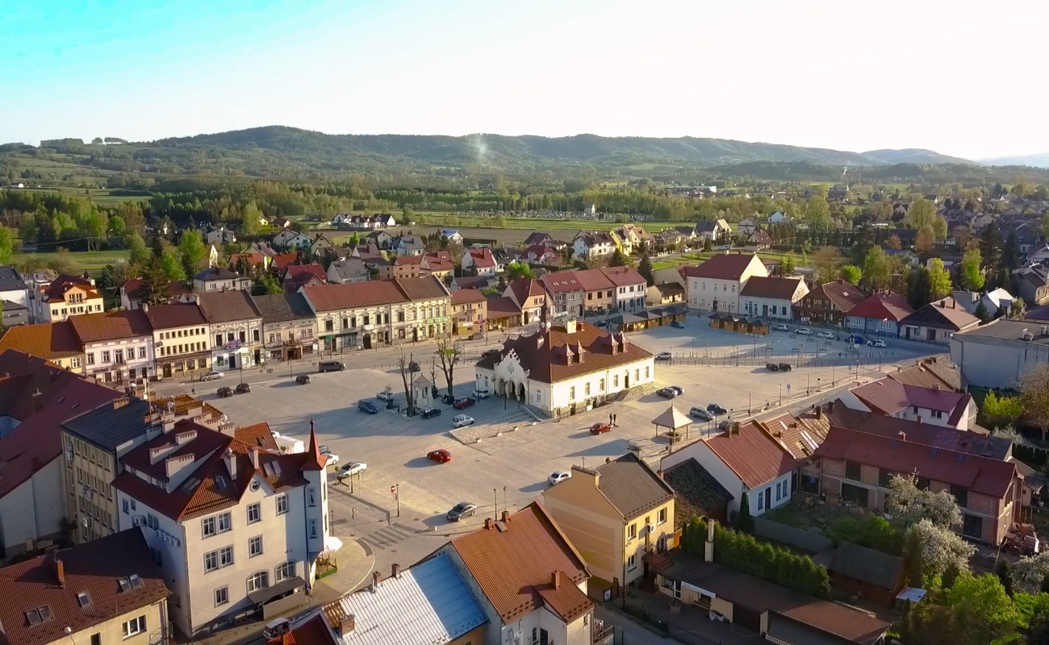

Deisylene Rocha

# Introduction

This budget aims to present a cost estimate for the implementation of a Wi-Fi internet network in rural and semi-urban areas of the Zakliczyn region, as shown in the satellite image. The proposal seeks to distribute internet signal among multiple strategic points using long-range radios and external access points to ensure stable and high-quality coverage. The network will be based on wireless technology (point-to-point and point-to-multipoint Wi-Fi), suitable for terrains with varied distances and natural obstacles.

# Network Installation Locations

Uma imagem com captura de ecrã, mapa

Os conteúdos gerados por IA podem estar incorretos.

The image shows an aerial view of the Zakliczyn region in Poland, captured by Google Earth. It depicts rural areas, farmland, villages, and the Dunajec River running from west to east. Various points are marked with blue icons connected by yellow lines, indicating possible installation or coverage locations for an internet network. The localities of Charzewice, Roztoka, Kończyska, and Zakliczyn are visible, suggesting a Wi-Fi signal distribution plan at strategic points throughout the area.

**Budget – Wireless Internet Installation**

**Estimated distance:** 6,793.47 meters

Itens Orçamentados (valores em euros):

|  |  |  |  |
| --- | --- | --- | --- |
| **Item** | **Quantity** | **Unit price (Euro)** | **Total (Euro)** |
| Main Router (PT) | 1 | 92.59 | 92.59 |
| Wireless Router WRT300N | 7 | 51.85 | 362.95 |
| Long-range directional antennas (24dBi) | 1 | 69.00 | 483.00 |
| Outdoor cables (Shielded Cat6 – 70m/unit) | 7 | 48.00 | 336.00 |
| Support/tube for antenna elevation | 7 | 36.00 | 252.00 |
| Power stabilizer (optional) | 7 | 24.07 | 168.49 |
| Labor – high-altitude installation & alignment | 8 | 65.00 | 520.00 |
| Configuration and testing with wireless link | 1 | 178.15 | 178.15 |
| **Total Geral(euro)** | 2 293.18 | | |
| **Total Geral(zloty)** | 9 835.04 | | |

- Equipment positioned on elevated locations or makeshift towers

- Conversion based on 1 EUR = 4.29 PLN

- 12-month equipment warranty

- Estimated installation time: 10 business days

- Includes signal testing, alignment, and basic technical documentation